Name_____________________________ Period_______
Geologic Time Scale Informational Guide
Earth Science
For this project you will be creating an informational guide over the geologic time scale. It may be created a variety of different ways. You can make a traditional book, a flipbook, a foldable, ect… Be creative! The following rubric will guide you along the way. This is an individual project that will be worth a total of 50 points. To get the full points use your work time efficiently and do your best!
Terms to Include:
Precambrian Time Cretaceous Period
Paleozoic Era Tertiary Period
Mesozoic Era Quaternary Period
Cenozoic Era Devonian Period
Cambrian Period Permian Period
Ordovician Period Triassic Period
Silurian Period Jurassic Period
Carboniferous Period

*To find information over the geologic time scale look to pages 118-129 AND R4 and R5 in the back of your book. You may also use credible, online, resources.
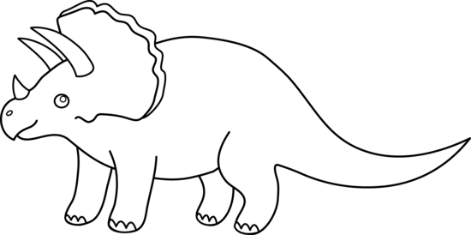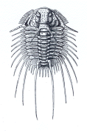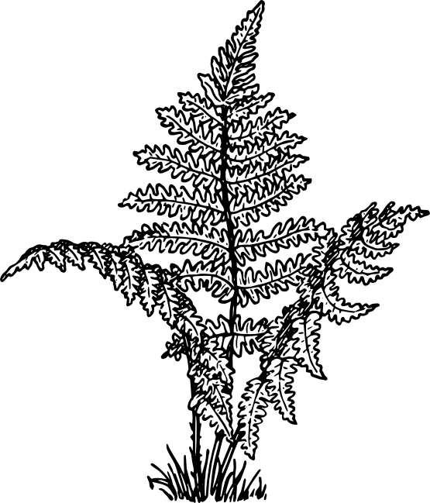
Name____________________________ Period______
Points | 9-10 | 7-8 | 5-6 | 3-4 | 2-1
Vocabulary Terms | All vocabulary terms are included | Most of the vocabulary terms are included | Many of the vocabulary terms are included | Few of the vocabulary terms are included | Little to none of the vocabulary terms are included
Timeline with Eras/Periods | All Eras and Periods are included | Most Eras and Periods are included | Many Eras and Periods are included | Few Eras and Periods are included | Little to none Eras and Periods are included
Organisms | 9 or 10 plants/animals included | 7 or 8 plants/animals included | 5 or 6 plants/animals included | 3 or 4 plants/animals included | 2 or 1 plants/animals included
Facts | 5 or more facts included | 4 facts included | 3 facts included | 2 facts included | 1 fact included
Neatness  &  Color | Neatness and color are done to the students very best ability | Mostly neat and colorful | Average neatness and color | Little neatness/color | Not neat/ not colorful

